Ideation Phase
Empathize & Discover
Date: | 20-12-2025
Team ID:
Project Name: | Bookstore
Maximum Marks: | 4 Marks

Empathy Map Canvas
The Empathy Map Canvas is used to understand the needs, frustrations, goals, and behaviors of users interacting with the Bookstore platform. This phase focuses on gaining insights into customers (buyers), sellers, and administrators to design a user-centric and efficient online bookstore.
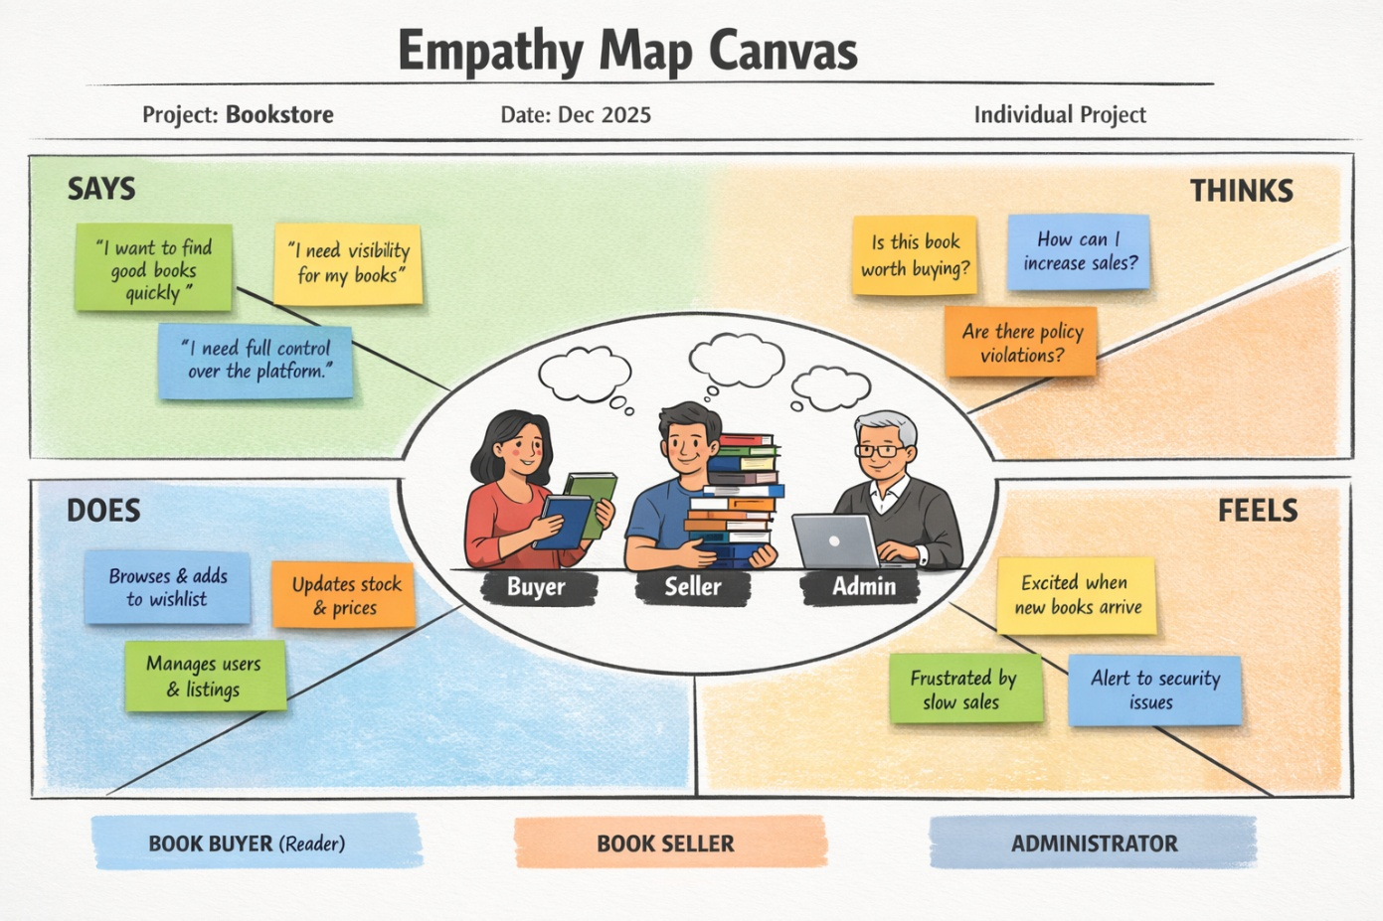
Reference:
https://www.mural.co/templates/empathy-map-canvas

Target Users
- Book Buyers (Readers)
- Book Sellers
- Platform Administrator

Empathy Map – Book Buyer (User)
Says
- “I want to find good books quickly.”
- “I prefer books with good ratings and reviews.”
- “I want an easy checkout process.”
Thinks
- Is this book worth buying?
- Are there better options at a similar price?
- Can I trust this seller?
Does
- Browses books by category and ratings.
- Adds books to wishlist or cart.
- Reads reviews before purchasing.
Feels
- Excited when discovering new arrivals.
- Frustrated when books are hard to find.
- Satisfied when the buying process is smooth.

Empathy Map – Book Seller
Says
- “I want to add and manage my books easily.”
- “I need visibility for my books.”
- “I want clear order details.”
Thinks
- Are my books reaching the right customers?
- How can I increase sales?
- Is my inventory updated correctly?
Does
- Adds new books to the platform.
- Updates stock and pricing.
- Tracks orders through the seller dashboard.
Feels
- Motivated when sales increase.
- Concerned about inventory management.
- Confident with a clear and organized dashboard.

Empathy Map – Administrator
Says
- “I need full control over the platform.”
- “User and seller management must be secure.”
- “The system should be reliable.”
Thinks
- Are there any policy violations?
- Is the platform running smoothly?
- Are users and sellers properly verified?
Does
- Manages users and sellers.
- Monitors book listings.
- Ensures system security and data integrity.
Feels
- Responsible for platform stability.
- Confident when controls are centralized.
- Alert to potential misuse.

Outcome of Empathize & Discover Phase
This phase helped identify real user needs and pain points, enabling the development of features such as wishlist functionality, rating-based book display, seller dashboards, role-based authentication, and admin controls in the Bookstore application.

